**The Battle of Neighborhoods**

**Dubai**

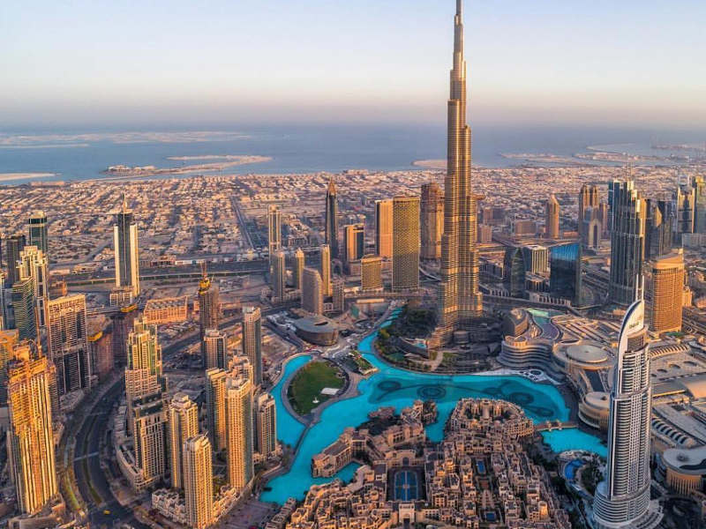

**1.Introduction**

Dubai is one of the seven emirates that in the United Arab Emirates. Dubai is the emirate of the United Arab Emirates with the highest population and the second largest area (4.114 km²) after Abu Dhabi. Today, Dubai is a commercial and cultural hub as a globally developing city in the Middle East and Persian Gulf region. Although the economy of Dubai has historically been founded on the oil industry, the Emirate has created important revenue items in the fields of tourism, airlines, real estate transactions and financial services, which it conducts with western-style business methods. Dubai has recently attracted the attention of the world with its large-scale construction projects and sporting events. As a result, thousands of tourists and expats go to Dubai every year.

The project’s aim is to help the new expats and tourists who have difficulties to find suitable places. So, using the foursquare API, you can view the restaurant, park, beach, etc. I made various analyzes to find the best place for them. The analysis of the two most visited and settled neighborhoods is also included in this project. This can help Dubai's new guests to get an overview of the places.

1. **Data Description**

For this project, the Foursquare API is used. A list of neighborhoods in Dubai is downloaded and their respective location in longitude and latitude coordinates is obtained from <https://en.wikipedia.org/wiki/List_of_communities_in_Dubai>. The data is can be seen below.

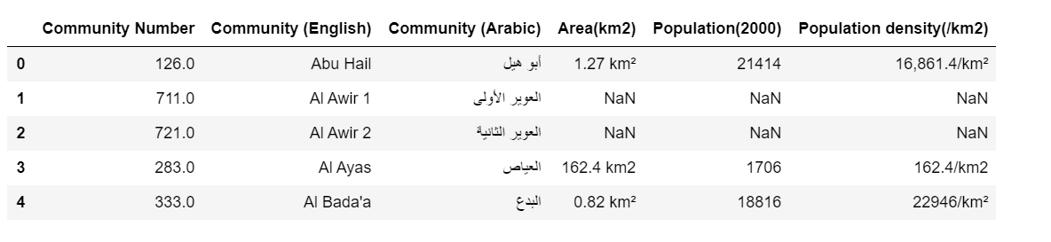

I only used Community (English) column and changed the column name to Community; others are dropped. Moreover, communities’ latitude and longitude values are added. I used ‘geopy’ library in order to find the latitude and longitude values of each community.

